**4.3** – delete from flughafen where iata_code = 'FRA';

delete 'FRA' unsuccessfully by using in FLUGVERBINDUNG “on delete restrict”

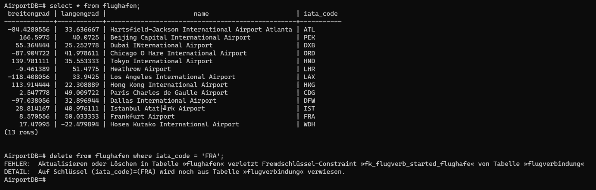

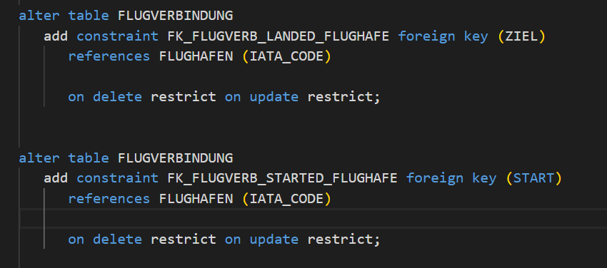

The reason for this strange phenomenon is:

* The following flight from this airport cannot be deleted because the primary key is in the Table Departures and Booking is referenced. This means that with **on delete restrict** all Parent rows (like a superior class) cannot be deleted if child rows (like the subordinate) exist that refer to the value of those parent rows.

e.g.:

FLUGVERBINGUNG 🡪 FLUGHAFEN (🡪 means vererbung in class diagramm)

* Delete a value in flughafen will affect the referenced one in flugverbindung
* On delete restrict will not allow it
* With **on delete cascade**, on the other hand, all subordinate data records or in the referencing tables are also deleted when the superordinate data record is deleted, so that the referential integrity is not violated, which was not the case here
* On delete cascade allows it
* Delete a value in flughafen will subsequently delete the corresponding one in flugverbindung

delete 'FRA' successfully by using in FLUGVERBINDUNG “on delete cascade”

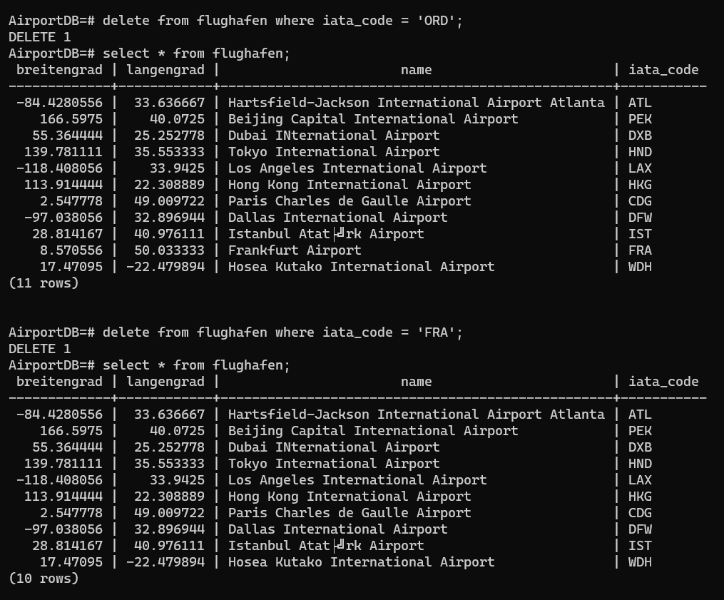

Because on delete cascade is being used

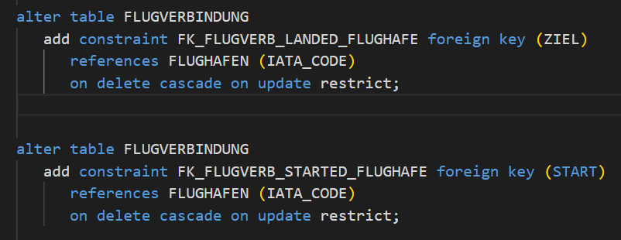

Delete ‘FRA’ or ‘ORD’ or whatever it may in FLUGHAFEN table will consequently delete the corresponding value in the other table, such as in FLUGVERBINDUNG table (the subordinate one of FLUGHAFEN)

